**-Lab Week 4A-**

**Problem 1 - Average Calculator: Calculate the average of the numbers the user enters. It will show the result when the user enters a negative number.**

Paste your code below:

sum = 0.0

n = 0

while (x := float(**input**("> "))) >= 0:

sum += x

n += 1

**print**(sum / n)

Paste the screenshot of your output below:

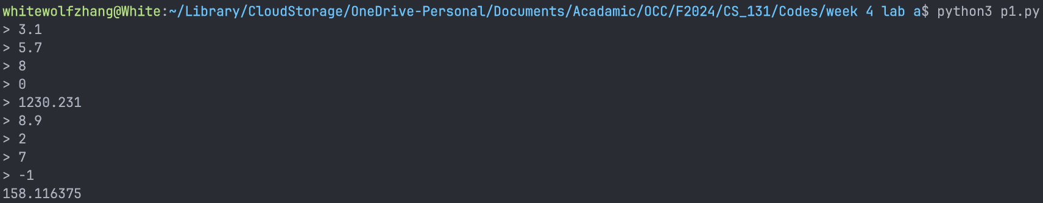

**Problem 2 – Minimum Number: Find the minimum number from the numbers the user enters. It will show the result when the user enters a negative number.**

Paste your code below:

from math import inf

min = inf

while (x := float(**input**("> "))) >= 0:

if x < min:

min = x

**print**(min)

Paste the screenshot of your output below:

